As of February 12, 2025 Part 1
What has changed at Manchester City between the 2023–2024 and 2024–2025 seasons? Is it all about Rodri's influence? Perhaps, but the difference goes deeper. Let’s break it down.
Team Performance
In 2023–24, City were a well-oiled machine; 96 goals in 38 games, averaging 2.53 per match. This season? They’ve scored just 48 in 24, down to 2.00 per match. Still solid, but not quite surgical.
Defensively, the drop-off is more glaring. They’re conceding 1.46 goals per game now, up from just 0.89 last season. It’s not panic mode, but something’s clearly not clicking.

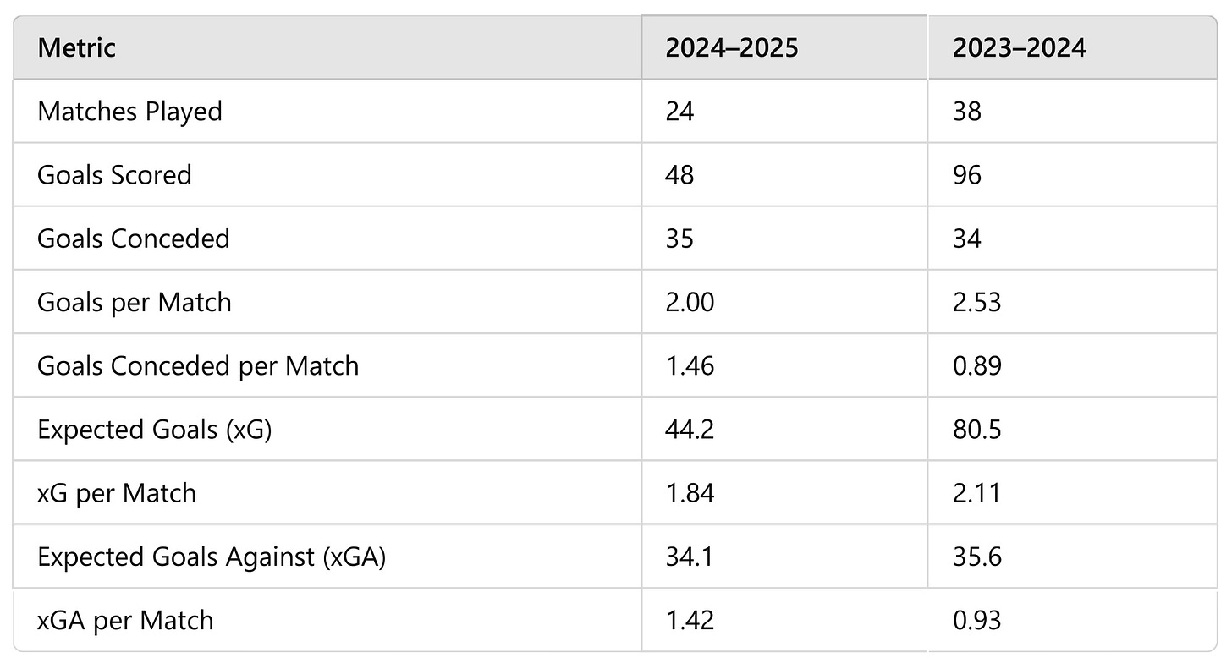

Haaland Still Haaland. But…
Erling Haaland leads City again. 19 goals in 24 matches this season. That’s 0.79 per game. Yet, even he’s slightly off his 2023–24 pace of 0.87. And behind him? The firepower looks dimmer.
Phil Foden has dropped from 19 goals last season to just 7 so far. Julian Alvarez, once a key figure, isn’t in the spotlight anymore.

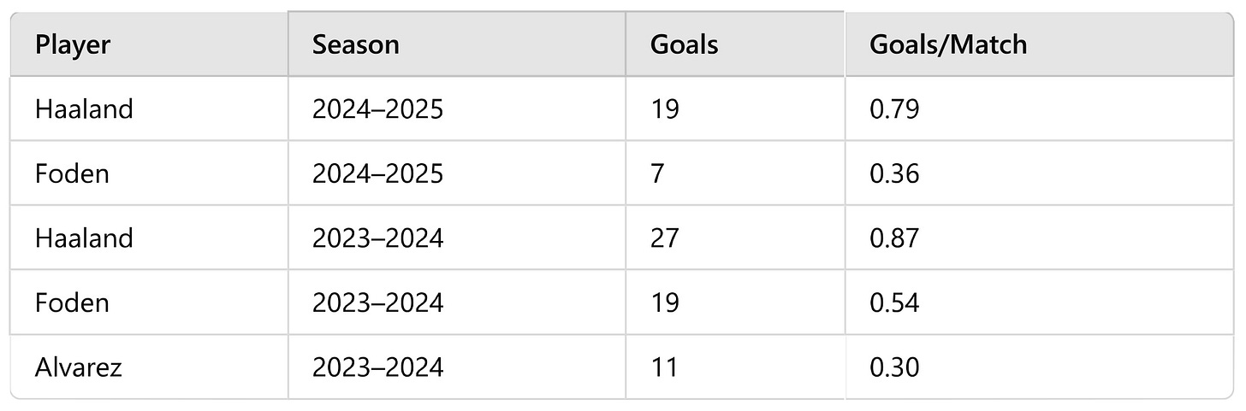

Efficiency Drop Across the Board
When comparing Manchester City’s core performance metrics from 2023–24 to 2024–25, the decline is hard to miss. The team is scoring fewer goals per match (2.00 vs 2.53) while conceding more frequently (1.46 vs 0.89). Their expected goals (xG) has also dipped from 2.11 to 1.84 per match, highlighting a clear reduction in offensive threat.
On the defensive side, the xGA (expected goals against) has risen from 0.93 to 1.42, indicating that City are giving up better chances to opponents.
Even Erling Haaland, while still top-class, isn’t quite at last season’s pace, his goals-per-game average has dropped from 0.87 to 0.79. The small drop may seem negligible, but for a striker of his caliber, it reflects the larger story: City aren't as clinical, composed, or dominant as they were just a season ago.

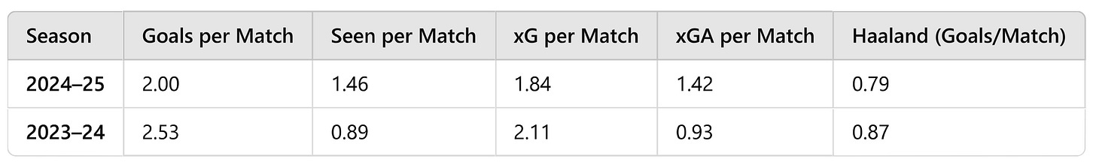

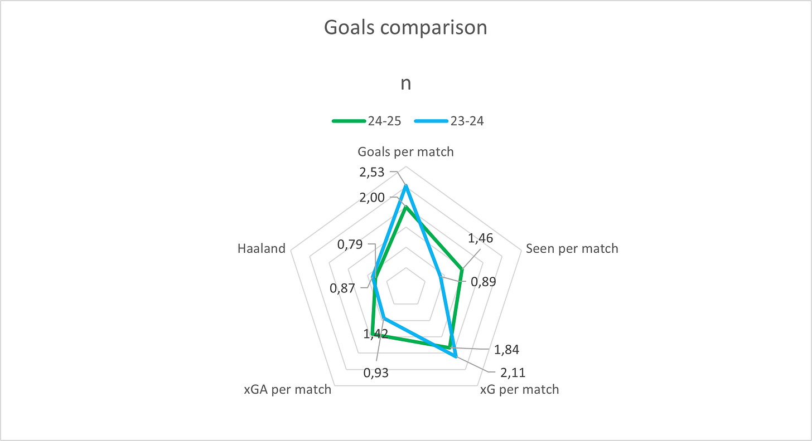

Where’s the Creative Spark?
Kevin De Bruyne is still chipping in (6 assists), and newcomer Savio is matching that. But compare that to De Bruyne’s 10 assists last year and you see the drop. The midfield isn’t quite as incisive.

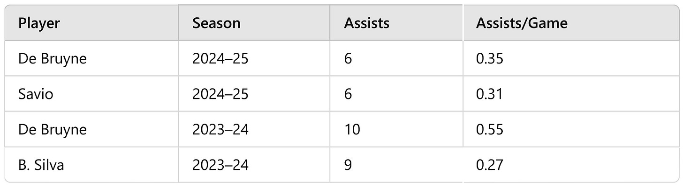

Progression & Possession: Something’s missing
Jeremy Doku is still City’s dribbling engine, but even he’s carrying the ball forward less. Rodri; last year’s pass master is nowhere near his previous numbers in progressive passes. In his place? Gvardiol and Akanji are trying, but the rhythm has changed.

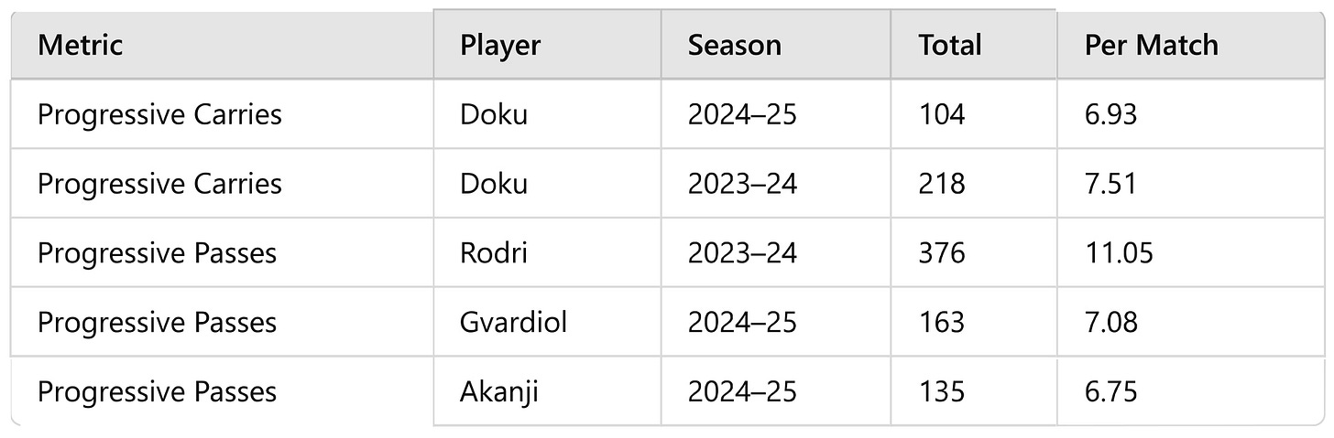

What Happened to Foden?
Last season, Phil Foden was everywhere: 35 games, 19 goals, 2857 minutes. This year? He’s played 19 times, started only 15, and logged just 1364 minutes. Injuries? Rotation? Either way, City are feeling his absence in the final third.
Tactical Tweaks: New Looks, New Struggles
Guardiola’s tinkering again. City used 4-2-3-1 in 42% of matches this season — similar to last year. But there's more 4-1-4-1, more variation, less structure. And maybe that’s part of the inconsistency.

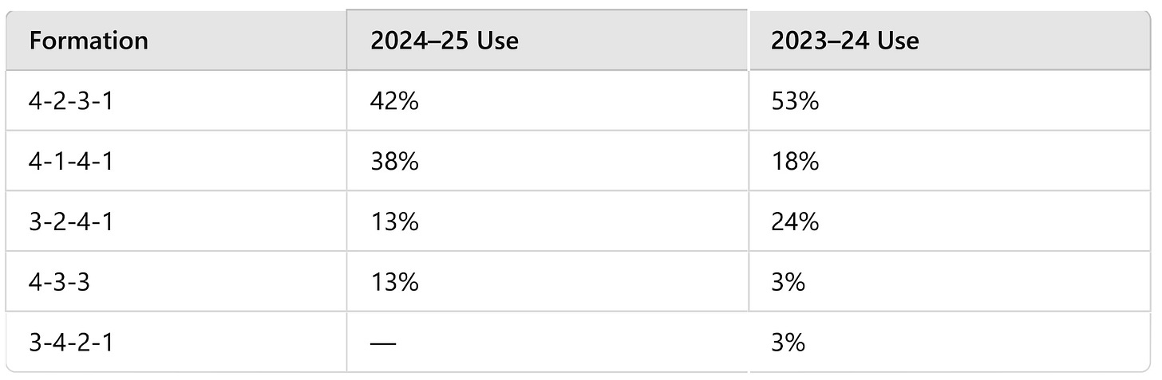

Passing Network: From Precision to Redistribution
The midfield in 2023–24 was a passing powerhouse, with Rodri operating as the undisputed hub. His stats were astounding:
- 3365 completed passes at 92% accuracy
- Nearly 99 passes per game. A number that towered over every teammate
- Add to that 1676 completed short passes and 340 long balls at an 85% success rate; all elite marks
Alongside him, Ruben Dias (2469 passes at 94%) and Akanji (2180 at 93%) provided consistent and safe outlets from the back.
In 2024–25, the responsibility has shifted, but the volume hasn’t returned.
- Gvardiol leads the passing charts now with 1515 completed passes (91%), but is averaging just 65.86 per game, a steep drop from Rodri’s 98.97.
- Akanji remains tidy and reliable at 1389 passes with 94% accuracy, and Ruben Dias keeps his 94% precision while averaging the highest per-game rate among defenders at 81.5.
- In terms of short passes, Gvardiol leads again (797, 94%), with Akanji close behind (666 at a superb 96%).
But the deeper build-up, especially long ball distribution has clearly shifted:
- Rodri’s 340 completed long passes at 85% last season is unmatched.
- This season, Ederson has taken on more of that role, but with less precision: 112 long passes at just 62%. Ruben Dias has 56 at 75%, but the volume is much lower.
Per Match Passing Stats: 2024–25 vs 2023–24

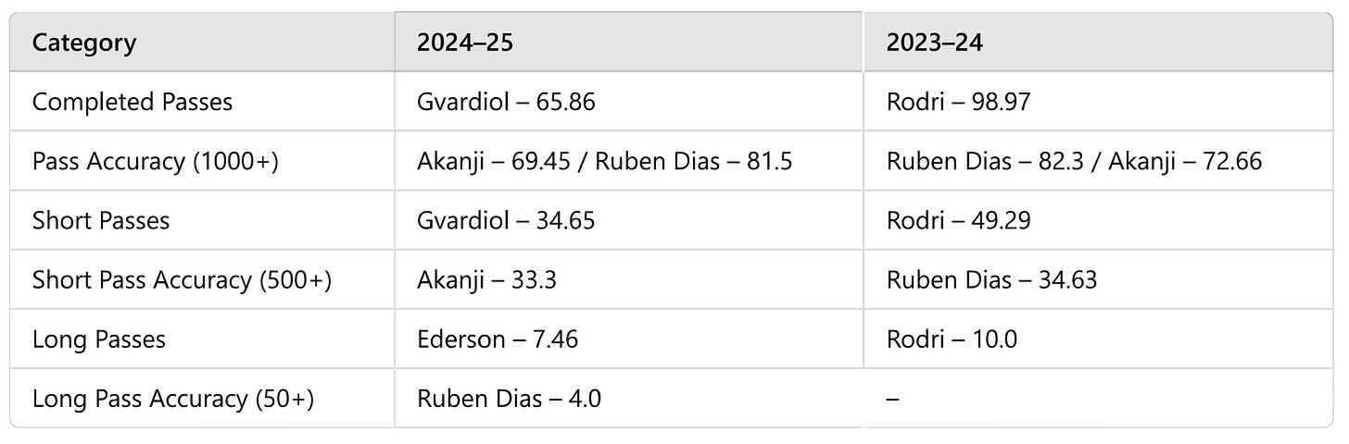

Per Match Passing Comparison

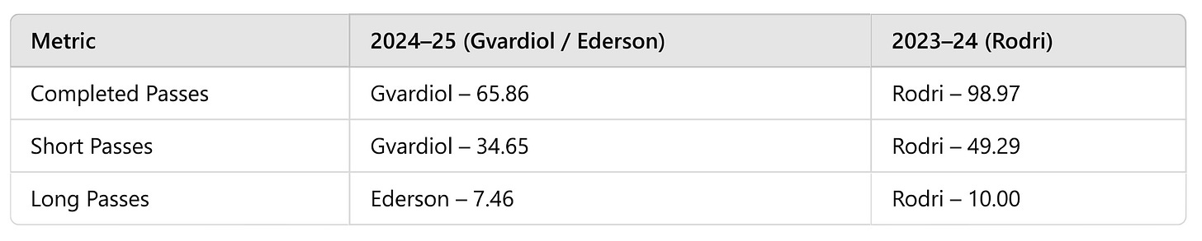

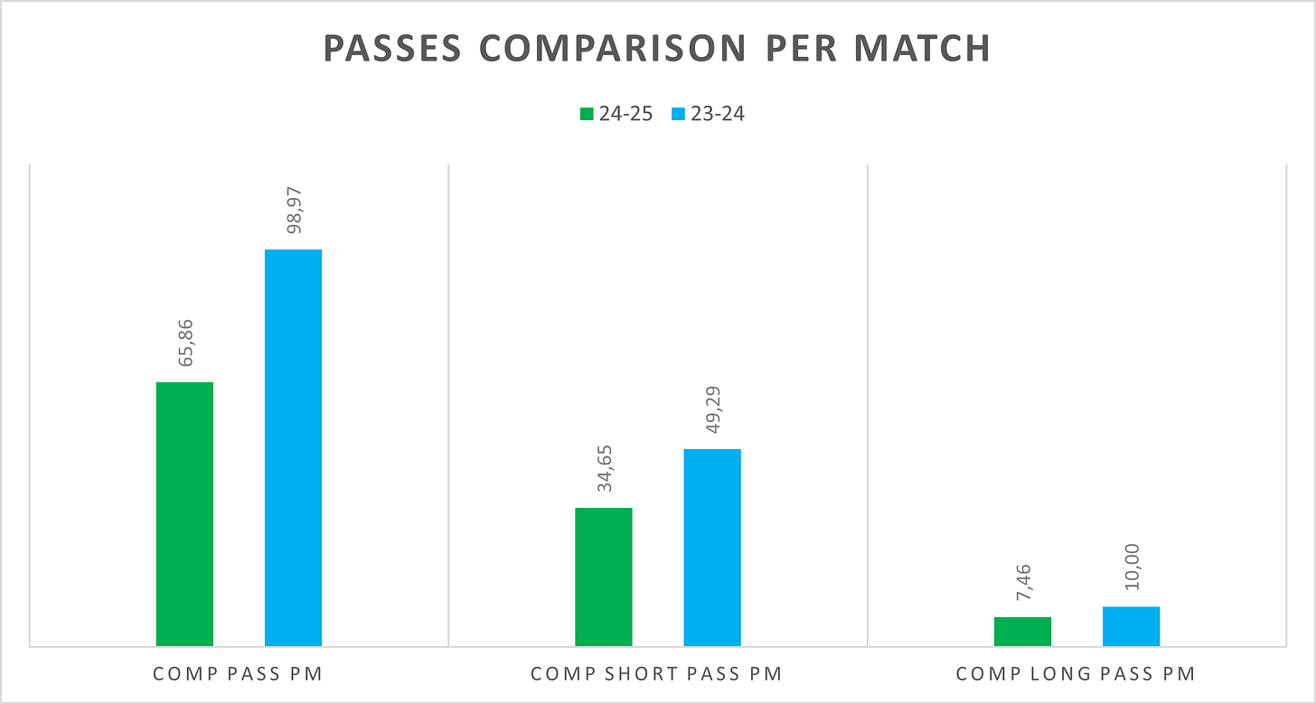

To Be Continued…
This wraps up Part 1 of the Manchester City 2024–25 vs 2023–24 data report, focusing on general performance, midfield control, and passing structure. In Part 2, we’ll dive into key passes, shooting efficiency, defensive stability, and goalkeeping performance.
Stay tuned.
Data Sources
All statistical data used in this report has been sourced from FBref and FootballCritic.

Part 2
In Part 2, we’ll break down Manchester City’s key pass output, shot quality, defensive structure, and goalkeeping performance, comparing how these elements evolved from the 2023–24 season to the current 2024–25 campaign.
We begin with creativity: who’s delivering the key passes, and how has that changed?
Key Passes Take a Hit
Manchester City’s attacking creativity has clearly dipped, especially when it comes to producing those all-important key passes; the final ball before a shot.
- Kevin De Bruyne, the heartbeat of City’s creativity, averaged 3.27 key passes per match in 2023–24; the best in the league. This season? He’s down to 2.29. Still elite, but less frequent.
- Bernardo Silva also dropped slightly, from 1.93 to 1.65; a sign of City's general slowdown in midfield playmaking.
- Phil Foden, another major creative force, is also below last year’s pace; 1.84 this season vs 2.08 previously.
- One of the more subtle shifts this season? Julian Alvarez is no longer at the Etihad. The Argentine forward, who averaged 1.86 key passes per match in 2023–24, has since transferred to Atletico Madrid.

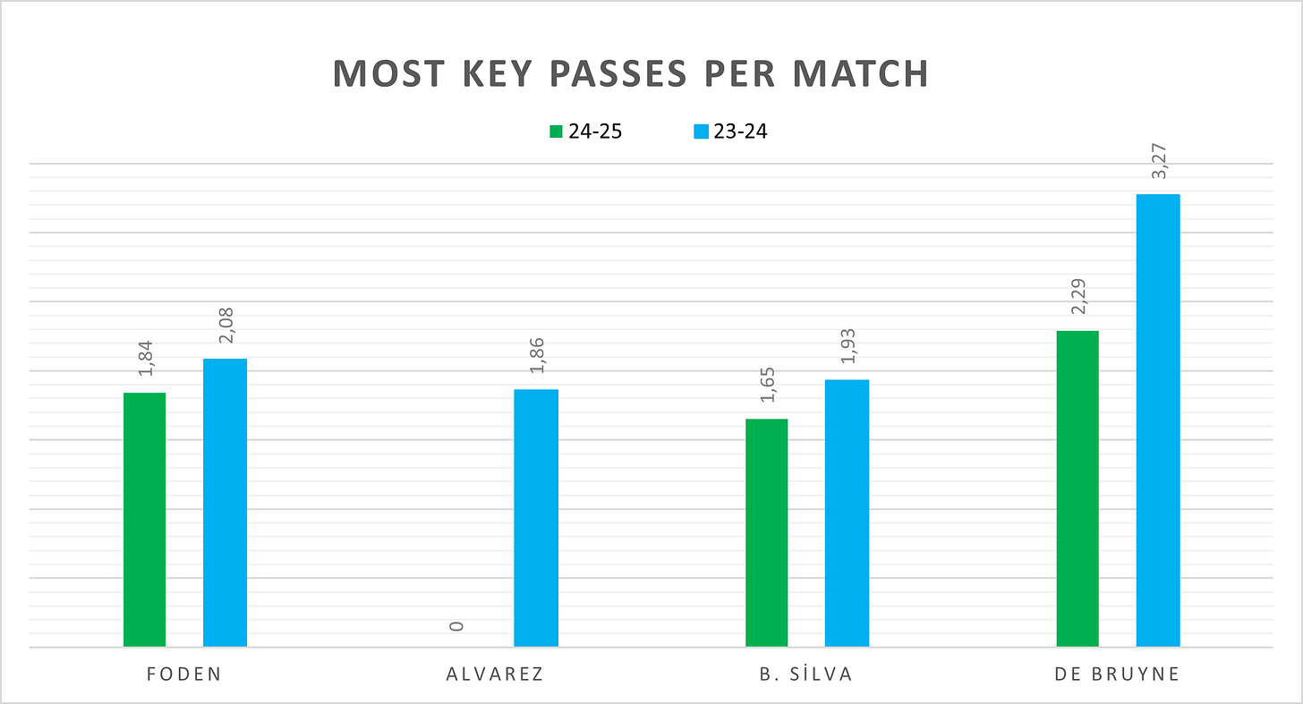

Shooting Trends: Fewer Shots, Less Threat
Manchester City’s shooting stats in 2024–25 tell a familiar story; less volume, less accuracy, and slightly lower efficiency across the board.
- Erling Haaland remains the dominant figure, with 90 shots this season (3.75 per match), nearly identical in volume to last season (113, 3.64). Interestingly, his shots on target have held steady at 50; but due to fewer games played, he’s now averaging 2.08 shots on target per match, up from 1.61.
- Phil Foden, meanwhile, has seen his output cut nearly in half; from 105 shots and 48 on target in 2023–24 to 45 shots and 14 on target this season.
- Savio has quietly emerged as a contributor, with 15 shots on target (0.78 per match), offering secondary threat behind Haaland and Foden.
When it comes to shot quality and efficiency, the picture gets sharper:
- Foden leads the team in shooting efficiency with a 50% goal conversion rate from shots on target (minimum 5 goals); a standout stat for a midfielder.
- Last season, that honor belonged to Haaland, who converted 54% of his on-target shots.
At the team level:
  - 2023–24: 683 total shots, 264 on target — averaging 17.97 shots per game and 6.95 on target.
  - 2024–25: 400 total shots, 141 on target — down to 16.67 shots per game and 5.88 on target.
So City are shooting less, hitting the target less often, and relying more heavily on Haaland’s consistency. Foden’s sharp finishing is a silver lining, but overall, the attack has lost some of its cutting edge.

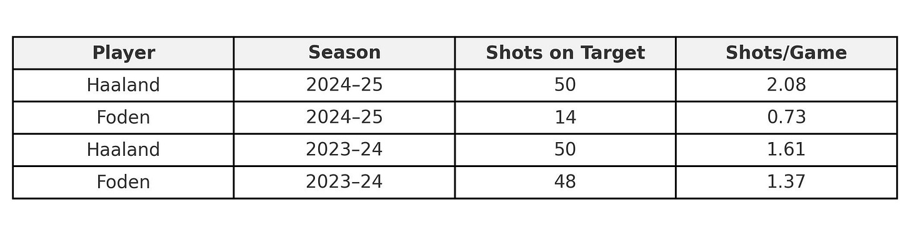

Tackling Trends: Grit vs Control
In 2023–24, Manchester City's tackling metrics painted a picture of controlled disruption, led primarily by Rodri and supported by the backline and midfielders.
- Rodri completed 70 tackles (2.05 per match), winning 43 of them, and was active both in the defensive third (25) and the middle third (33). His tackling style wasn’t just about volume; it was strategic and smart.
- Akanji, meanwhile, boasted a 67% tackle success rate (40+ attempts), adding efficiency to City's structure.
Fast forward to 2024–25, and the picture is different.
- Mateo Kovacic has taken the brunt of City’s defensive duties in midfield. He leads in:
  - Total tackles: 46 (2.30 per match)
  - Tackles won: 27 (1.35)
  - Tackles in the middle third: 26 (1.30)
  - Dribbles tackled: 22 (1.10)
  - But also in tackles lost: 26 (1.30)
His presence is everywhere, but his win rate suggests a more aggressive, less controlled approach than Rodri's.
- Josko Gvardiol has stepped into a broader defensive role, contributing:
  - 36 total tackles (1.56 per match)
  - 16 in the defensive third (0.69)
  - 33 tackles won last season, showing his growth and adaptability
- Bernardo Silva, as always, brings understated value. While not in the highest volume, he’s:
  - Among the most efficient tacklers, with a 75% success rate (on 20+ attempts)
  - Responsible for 24 tackles won and 18 dribble stops this season
  - Previously led the team in tackles lost (32) in 2023–24, but has tightened up in 2024–25
The difference is clear: Rodri’s calm, composed tackling was the axis of City’s defensive rhythm last season. In 2024–25, the work has been redistributed — but it’s more chaotic. Kovacic brings effort and volume, but not the same control. Gvardiol is increasingly active higher up the pitch. And Silva continues to glue things together, both with and without the ball. The result? City are still defensively solid, but with a very different feel.
Final Line of Defense: Gvardiol Everywhere
As City evolved defensively in 2024–25, one name keeps popping up across the backline: Josko Gvardiol. He’s now the club’s leader in:
- Shots blocked: 13 (0.56 per match)
- Interceptions: 25 (1.08 per match)
- Clearances: 68 (2.95 per match)
Gvardiol is clearly doing the heavy lifting defensively — both in volume and variety. But that last stat shows the burden might be a bit too much at times.
Meanwhile, Bernardo Silva continues his do-it-all role higher up the pitch, leading in pass blocks (17), followed closely by Rico Lewis (16), who has quietly become a very reliable presence in wide and midfield spaces.
Last season, though, City’s defensive workload was more evenly spread:
- Ruben Dias led in shots blocked (17), clearances (77), and interceptions (30).
- Foden, Alvarez, and Silva all had 28–30 pass blocks, reflecting a more active front-line pressing unit.
- Interceptions were a group effort too, with Walker and Gvardiol matching Dias’ volume.
As for errors? Rodri made just 4 all season in 2023–24. Gvardiol had only 3. But this year? He’s already up to 5 errors leading to shots; a clear sign of just how much more pressure he’s under in 2024–25.

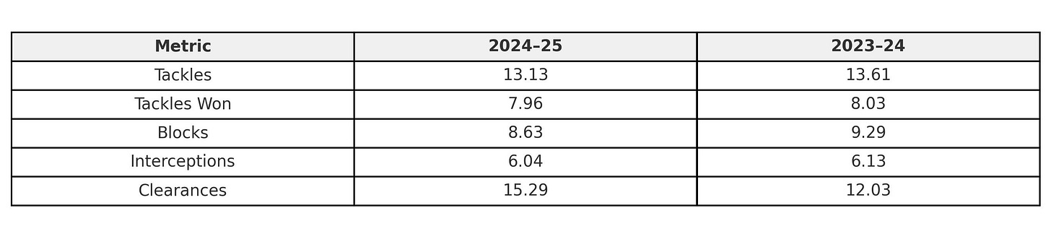

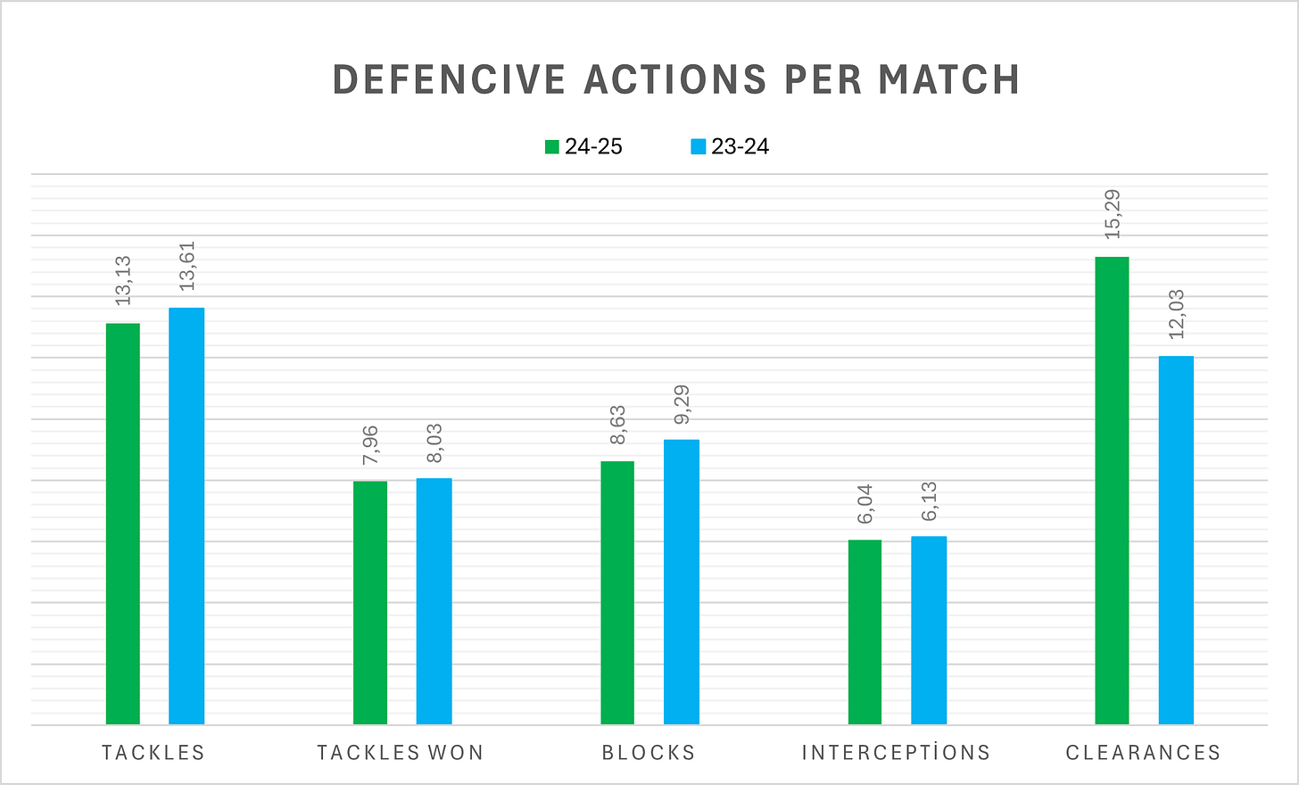

Goalkeeping Shift: From Steady to Shaky?
The goalkeeper situation at City has shifted more than usual this season — not only in terms of who's starting, but also in performance output.
In 2023–24, Ederson played 33 matches, while Ortega stepped in for just 9. This season, it’s more even — Ederson with 15 starts, Ortega with 9. And the numbers show a clear difference in their impacts.
- Ederson has seen a noticeable drop in form:
  - Goals conceded per game rose from 0.82 to 1.33
  - Save percentage fell from 68% to 58%
  - Post-shot xG per match nearly doubled, from 0.82 to 1.43
- Ortega, meanwhile, has been slightly more efficient this season than Ederson:
  - Concedes 1.67 goals per match, but makes 2.89 saves per game (up from 2.22 last year)
  - Maintains a 63% save rate, better than Ederson’s 58%
  - Handles more shots on target - 4.56 per game vs Ederson’s 3.67)
  - Ortega’s PSxG remains consistent - 1.00 to 1.49; showing he’s been reliable in tough moments, even under more pressure.
In terms of defensive actions outside the penalty area — an area where Ederson usually thrives; he’s also down:
  - From 1.52 per match to 1.87, still active but not as commanding
  - Ortega’s number here has dropped too, from 1.44 to just 1.00
City’s goalkeeping dynamic has changed — less consistency from Ederson, and more action for Ortega. Neither has matched the efficiency levels of last season, especially when it comes to goals conceded and shot-stopping percentages. The increased shot volume against them suggests the defense isn’t offering the same protection either.

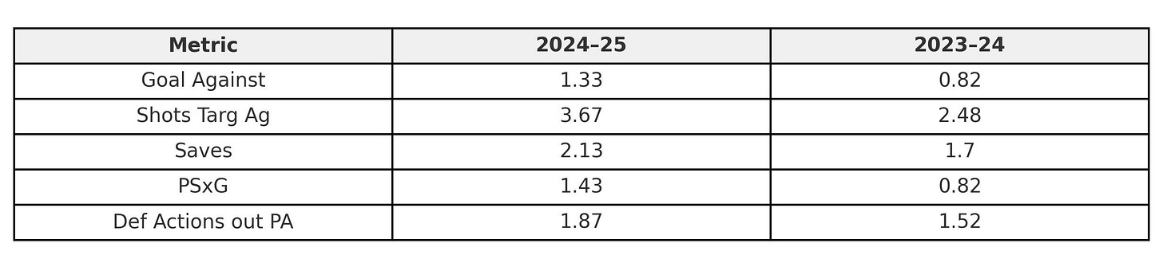

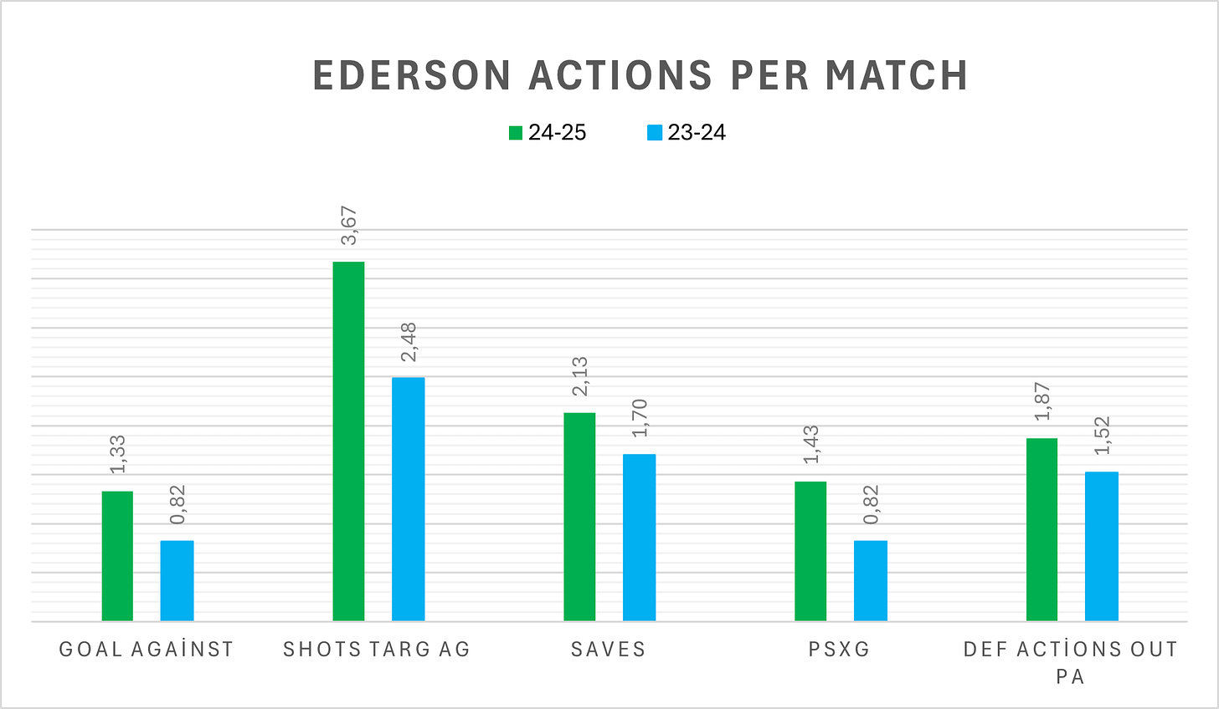

Conclusion: A Team in Transition
Manchester City’s 2024–25 season has been a story of change, adaptation, and subtle decline. The numbers don’t lie — from attacking sharpness to midfield control, defensive structure to goalkeeping reliability, the drop from last season’s dominance is visible in nearly every metric.
City are still a top-tier team; tactically intelligent, individually brilliant, but the cohesion, sharpness, and control that defined them in 2023–24 has slightly eroded. A team searching for its next rhythm.
Data Sources
All statistical data used in this report has been sourced from FBref.

